**Exp-5 Design a door bell using push button**

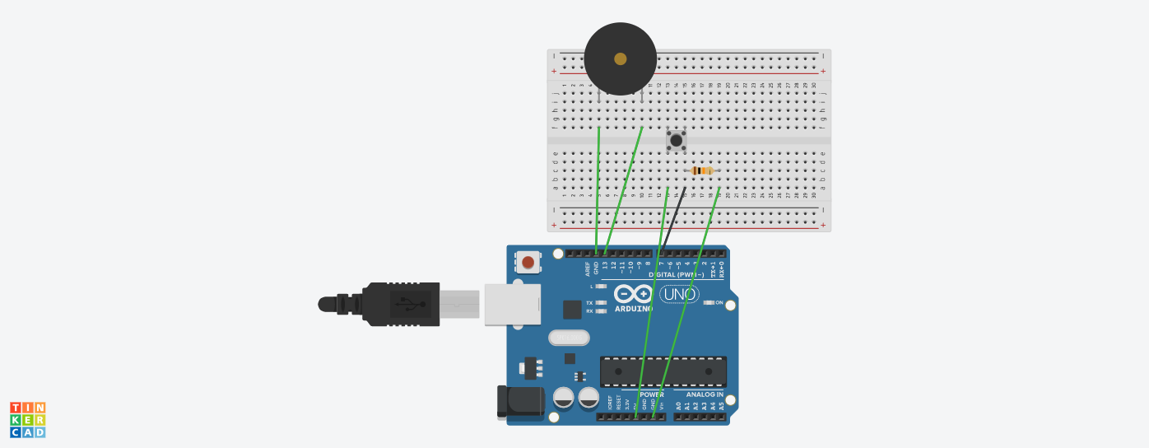

**Concept Used**

1. 2 digital pins of the Arduino are used where pin 2 is connecting the buzzer with Arduino. One ground pin is used as well.

2. One end of the switch is connected to the resistor of 10k ohm and to Digital pin 7 as well. Another is connected to the 5V supply.

3.The 10K ohm resistor is connected to the ground. When we press the switch, the buzzer will emit a beep sound.

4.Buzzer is connected to the 13 number pin and ground(GND) pin;

**Learning and Observations**

1.Whenever the switch is pressed, the buzzer emits sound corresponding to the coding done on the Arduino and connections made.

2.Arduino board has Digital pins and Analog pins.

Digital pin provides Input as well as Output, but Analog pin provides only input.

3.The Arduino board has ~ sign in Digital pin side which is also known as Pulse Width Modulation(PWM)**.**

These pins help’s in getting Analog signals with digital means.

**Problems and Troubleshooting**

1.There was a slight confusion in understanding the experiment and then making the required connections.

2.Some minor errors were there, which were trouble shooted by the correcting the code.

**Precautions**

1.The connections must be correct.

2. All the equipment must be in working condition.

3.The connections made on the pins of the Arduino must coincide with the codes written on the software.

4. The buzzer must be checked before connecting it to the circuit on the breadboard.

**Learning Outcomes**

1. Connection of different equipment like switch, buzzer, Arduino.

2. Learning the use of the switch.

3. Improvise the learning of the Arduino.

4.Using the buzzer.